**Department of (Computer Science)**

**Pak-Austria** Fachhochschule**: Institute of Applied Sciences and Technology, Haripur, Pakistan**

**COMP-112L Object Oriented Programming Lab**

**Lab Journal**

**Class: BS Computer Science**

**Name: Ahmed Raza**

**Registration No.: B20F0436CS031**

**Semester: 3rd**

**Submission Date: 08 February, 2022**

**Submitted to: Engr. Rafi-Ullah**

**__________________**

**Instructor Signature**

**Lab No. 06**

**Classes using Set & Get Function**

**Objectives:**

In this lab we will be discussing about Classes by using Set & Get Functions in detail. One of the most important concepts in object-oriented programming is that of inheritance.

**Tools/Software Required:**

* All the tasks are implemented on DEV C++.

**Introduction:**

This is also called Data **Encapsulation**, is to make sure that "sensitive" data is hidden from users. To achieve this, you must declare class variables/attributes as **private** (cannot be accessed from outside the class). If you want others to read or modify the value of a private member, you can provide public **get** and **set** methods.

**Access Private Members:**

To access a private attribute, use public "get" and "set" methods.

**Lab Tasks:**

**Task # 01:**

**Write a code in which we use set and get function.**

**Code:**

**#include <iostream>**

**using namespace std;**

**class Employee {**

**private:**

**// Private attribute**

**int salary;**

**public:**

**// Setter**

**void setSalary(int s) {**

**salary = s;**

**}**

**// Getter**

**int getSalary() {**

**return salary;**

**}**

**};**

**int main() {**

**Employee myObj;**

**myObj.setSalary(50000);**

**cout << myObj.getSalary();**

**return 0;**

**}**

**Output:**

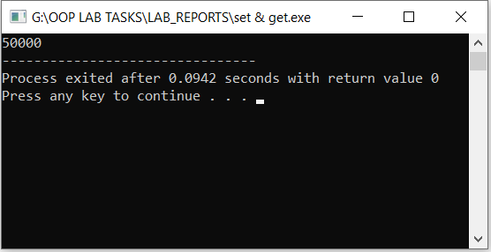

**Results & Observations:**

In this Lab I’ve learned about the concept of Data Encapsulation means that how we access the private data in the class by using set & get function. In the upper example I’ve created Employee class and it’s having member variable **salary** that’s private so by using setter & getter function I can access that variable .